University of Greenwich

BSc Hons Computer Science: Games

PyAdventure - A Python programming video game.

By

Lyubomira Dimitrova

Due Date: 22/04/2024

Supervisors: Yasmine Arafa and Ralph Barthel

Acknowledgements

I would like to express my deepest gratitude to my supervisors for their invaluable guidance and support throughout the duration of this project.

I express my gratitude to Mrs. Yasmine Arafa for her perceptive criticism about the research parts of "PyAdventures" and her expert guidance on how to tackle any cheating difficulties in the game. Her advise had a vital role in enhancing the educational integrity and efficacy of the initiative.

Mr. Ralph Barthel has played a crucial role in developing and refining both the basic project concept and the proposal. The project's concept and execution have been much improved by his ideas for revisions, which have ensured a strong basis for the growth of "PyAdventures."

I would like to express my deep gratitude to Mr. Jon Weinel and Mr. Darren Lloyd Gent, who are the leaders of the games course module, for their invaluable and practical support during the game's creation. Their proficiency in game design and development played a crucial role in actualizing the educational ideals of "PyAdventures", guaranteeing that the game was both captivating and pedagogically robust.

Their combined passion, devotion, and attention to creating a cutting-edge learning atmosphere have greatly impacted my academic and professional development. I express my gratitude to Mr. Arafa, Mr. Barthel, Mr. Weinel, and Mr. Gent for their significant contributions and for serving as a source of inspiration during the course of my journey.

**Abstract**

In the field of game-based learning, PyAdventures represents as an innovative project designed to meet the increasing demand for engrossing and easily accessible coding instruction. This final report details the whole journey of PyAdventures, a game designed to explain and reinforce the fundamentals of Python programming for beginners. The game is primarily aimed at young adults and first-year university students who have little to no experience with coding.

Inspired by the idea of "gamification," the goal of this project was to change the way that education is taught by bringing together Python programming concepts into an engaging adventure game with a medieval fantasy theme. This study describes how the game was developed using iterative design and development stages made possible by the Unity game engine, starting with an educational theory, and ending with a rich, narrative-driven learning environment.

The game was developed using a hybrid technique that blended ideas of instructional design and adaptable development practices to produce a learning environment that was constructed. With its dynamic learning path covering many themed "Acts," PyAdventures is designed to introduce new programming structures while solidifying prior knowledge through more challenging tasks.

In this report, the outcomes of adaptive user testing sessions are provided. These sessions included a varied group of participants and applied both qualitative and quantitative feedback tools, such as a modified Microsoft Form survey. The information acquired was important in improving the game's overall efficacy and user experience by enhancing the user interface, instructional material delivery, and gaming mechanics.

With its creative path through the core ideas of Python programming, PyAdventures brings in an era of innovation in the gamification of education. This comprehensive documentation covers the story of PyAdventures' development and describes the thoughtful design decisions and instructional techniques that make this distinctive learning game. PyAdventures is a unique approach to code-writing exercises as it involves multiple-choice questions and drag-and-drop activities that encourage students to create code snippets and get a thorough understanding of programming logic.

In this version of PyAdventures, there is a new shop system that allows players to buy hints to help them through some of the more challenging parts of Python with coins they earn via game progress. Every chapter begins with a brief introduction that lays out the fundamentals for the learning objectives that follow. It wraps up with a summary quiz that reviews the material, ensuring a thorough retention of the material.

This work documents the development process and demonstrates the adaptable methodology that was used, which combined agile development with user-cantered instructional design in the dynamic Unity environment. The game's development has been significantly influenced by user feedback that was obtained using Microsoft Form surveys from certain groups of students. Improvements to the mechanics of the store system, the thoughtful placement of suggestions, and the storylines that open each chapter have all been influenced by this conversation with the end users.

PyAdventures has been effective at revealing Python, according to user evaluations, which show that users feel more competent and confident while programming. The shop system's integration of a virtual economy and strategic resource management further integrates critical thinking and decision-making abilities into the educational process.

PyAdventures essentially represents an ideal blend of enjoyment and utility, learning and involvement. It is a comprehensive learning experience that represents a progressive vision for educational technology, not merely a game. PyAdventures also aims to become the industry standard for interactive aspects that dramatically improve the learning experience for aspiring programmers.

Contents

Table Of Figures 8

1. Introduction 9

1.1. The Difficulty of Programming Education 9

1.2. Gamification: A Revolutionary Approach to Learning 10

1.3. Introducing PyAdventures 10

1.4. Purposes and Structure 10

2. Literature Review 12

2.1. What is Gamification? 12

2.2. What is Not Gamification? 14

2.1.1. Gamification Impact on PyAdventures 18

2.2. Theoretical Structure of Gamification 20

2.3. The implementation of gamification in the field of programming education. 20

2.4. Deficiencies and potential areas for improvement 22

2.5. Tackling the Difficulties of Implementing Gamification in Programming Education. 22

2.6. Distraction Potential 24

2.7. Manipulating the System 24

2.8. Overcoming Challenges with PyAdventures 25

2.9. Adaptive Learning and Feedback Mechanisms: 25

2.10. Theoretical Foundations of Gamification 25

2.10.1. Personalization in Gamification 26

2.10.2. Effective Game Design Principles 26

3. Project Design 28

3.1. Process of Development and Selection of Tools 28

3.2. Contemplating the Selection of Technology 29

3.3. Game Design Educational Goals: 29

3.4. Narrative Elements: 30

3.5. Shop System Functionality: 30

4. PyAdventures in the Context of Educational Programming Games. 31

4.1. CodeCombat 31

4.2. Tynker 32

4.3. CodeSpark 32

4.4. CodeMonkey 32

5. Methodology 34

5.1. Conception and Initial Development 34

5.2. Agile development and prototyping 35

5.3. Usability testing and gathering feedback from users 37

5.4. Assessing the Impact of Education 39

5.5. Identifying Limitations and Challenges 40

5.6. Constraints in Technology and Design 40

5.7. User feedback on Learning Effectiveness 43

5.8. Challenges in User Experience 43

5.9. Overcoming Constraints in Subsequent Research 43

6. Implementation 45

6.1. Development Tools and Environment 45

6.2. Game Mechanics Implementation 46

6.3. User Interface and Experience Design 48

6.4. Challenges Encountered 48

7. Testing and Validation 49

7.1. Testing Strategies 49

7.2. Users Feedback and Responses 49

7.3. Validation of Educational Objectives 50

7.4 Quality Assurance Processes 50

8. Discussion 51

8.1. Effectiveness of Gamification Techniques 51

8.2 User Engagement and Learning Outcomes 52

8.3 Challenges and Limitations 53

8.4. Educational Impact 53

9. Recommendations 55

9.1 Enhancements for PyAdventures 55

9.2 Future Research Directions 56

9.3 Potential Applications 58

10. In Conclusion 60

# Table Of Figures

Figure 1Main Menu 35

Figure 2 Map Design 36

Figure 3 Questions Template Design 37

Figure 4 Introduction to PyAdventures by Peter 38

Figure 5 Shop Design and Peter's Introduction to the Shop 39

Figure 6 Game Icon Design 41

Figure 7 Options Menu 42

Figure 8 End Of Game Design 44

# Introduction

Programming literacy is becoming just as important in the digital age as reading and writing. In the face of this paradigm change, traditional teaching approaches frequently fail to hold students' attention and keep them interested, especially when introducing difficult subjects like computer programming. Innovative methods that make learning not only efficient but also interesting and approachable are needed to meet this challenge. The use of games as a source of intrinsic motivation and engagement mechanisms to improve learning outcomes is known as gamification.

In an ever more digitalized society, the capacity to understand and regulate the structure of the software is no longer a specialisation and has become a fundamental form of literacy applicable to everyone. This transition highlights the significance of programming instruction as a fundamental aspect of modern learning. On the other hand, despite the importance of this talent, conventional training methods for programming typically have difficulties in captivating and motivating learners, creating a huge obstacle for many people to get started. The PyAdventures project was established with the goal of reimagining the educational path into the world of programming, taking into consideration the current circumstances.

## The Difficulty of Programming Education

Programming, particularly alongside a language as adaptable and extensively utilised as Python, is a field that merges rational reasoning with innovative troubleshooting. Despite this, the conceptual nature of coding and the first difficulty in learning might be intimidating for people new to it. Conventional educational paradigms, which heavily rely on memory and passive learning, are not well-suited to tackle the challenges they face. As a result, learners frequently feel overwhelmed and detached from how their abilities may be used in real-world situations.

## Gamification: A Revolutionary Approach to Learning

As a result of the limitations of traditional teaching approaches, educators and developers are now investigating the possibilities of gamification in learning. This approach incorporates game dynamics to enhance engagement, motivation, and recall of educational information. Gamification harnesses the built-in motivation of learners by including features like stories, challenges, and rewards to create a learning experience that is both effective and fundamentally pleasurable.

## Introducing PyAdventures

PyAdventures is a game-based learning platform that aims to demystify Python programming using an innovative way. PyAdventures incorporates programming problems inside an engaging story to guide learners through the essential concepts of Python, starting with fundamental syntax and constructions and progressing to advanced programming paradigms. The game's distinctive framework encourages players to acquire knowledge through practical experience, actively implementing concepts in numerous scenarios to solve tasks and develop in the narrative.

## Purposes and Structure

The main goals of PyAdventures could potentially be summed up in three ways:

In order to reduce the difficulty for beginners to get started, the game aims to offer a user-friendly and easy-to-understand introduction to Python programming that is appealing to individuals with various backgrounds and interests.

To promote engagement and retention: By utilising an interactive story that imbues the learning process with a sense of adventure, reinforcing concepts through application and repetition in a streamlined and pleasant manner.

For educators to establish a positive learning environment, it is important to embrace the concept of the fact that mistakes are an integral part of the learning process. Providing prompt and constructive feedback, as well as rewarding progress, allows to create confidence and competence in aspiring programmers.

PyAdventures is organised into chapters that cover different programming principles. It uses multiple-choice questions that evaluate theoretical understanding and drag-and-drop coding tasks for practice with code. The store system in place offers distinct encouragement to players based on their accomplishments, enabling them to get guidance and improve the learning process by making strategic choices. Quizzes at the end of each chapter highlight the information learned and help solidify and maintain the knowledge acquired, preparing for more difficult tasks.

Continuing to delve deeper into the report, the pedagogical will be investigated the underpinnings of PyAdventures, the design and development process that brought it to life, and the feedback-driven iterations that have refined its educational impact. The goal of this study is to offer an in-depth evaluation of PyAdventures' impact on the educational technology sector and its capacity to stimulate future advancements in programming instruction.

# Literature Review

## 2.1. What is Gamification?

When used efficiently game-based methods or gamification may properly engage, inform, and educate. Gabe Zichermann, author of the book "Game-Based Marketing," provides an easily understood summary of gamification as the use of game ideas and mechanics to effectively engage audiences while tackling challenges. Amy Jo Kim, the author of "Community Building on the Web" and a well-known creator of social games, has provided a clear overview of gamification as the use of game concepts to improve the attractiveness and engagement of different kinds of activities. According to The Gartner Ground, gamification is the practice of using game concepts in non-game environments, including innovation, marketing, training, employee performance, health, and social change.

By combining components from these definitions and eliminating the focus on encouraging individuals to perform tasks they typically find tedious, the term gamification can be defined as follows: "Gamification entails the utilisation of game-based mechanics, aesthetics, and game thinking to captivate individuals, stimulate action, facilitate learning, and address challenges."

• Based on games. The principles highlighted in the previously mentioned definition of "game" apply to the practice of gamification. The objective is to provide a framework where anyone who is learning, playing, consuming, or working is involved in a conceptual task that is governed by rules, interaction, and feedback, which leads to an accessible result that ideally inspires a psychological reaction. The objective is to develop a game that motivates individuals to dedicate their cognitive resources, time, and effort.

• Mechanical principles and concepts. The mechanics of playing a game encompass several elements such as levels, the acquisition of badges, point systems, scores, and time limitations. These are the components that are used in several games. Mechanics alone are insufficient to change a dull experience into an engaging one resembling a game, but they are essential foundational elements applied in the process of gamification.

• The study of aesthetics and the principles that determine it. In the absence of captivating visuals or a meticulously crafted interface, the use of gamification is unlikely to achieve success. The user interface, often known as the aesthetic and functional aspects of an experience, plays a crucial role in the gamification process. The visual perception of an event significantly impacts an individual's willingness to accept gamification.

• Game Thinking. Without a doubt, this is the fundamental component of gamification. The concept involves taking a basic action such as jogging or running and transforming it into an activity that has aspects of competition, teamwork, exploration, and storytelling. This is how running becomes a social activity. Friends engage in friendly competition while also providing support in a collaborative setting, as the runner recounts their experience of racing a distance of one thousand miles or escaping zombies. The administration of a virtual factory offers valuable insights into the operations of a real facility. Leadership talents are acquired by leading people on missions.

• Engage. The express objective of the gamification process is to capture an individual's attention and involve them in the established process. The basic objective of gamification is to actively involve individuals.

• People. These individuals can be defined as learners, consumers, or players. These are the people who will be involved in the established process and who will receive encouragement to take action.

• Motivate Action. Motivation is a dynamic process that provides energy and inspiration, as well as a sense of purpose and significance, to one's behaviour and activities. In order for individuals to be motivated, the task must be at an appropriate level of difficulty, neither too difficult nor too easy. Encouraging involvement in a certain action or activity is a fundamental aspect of gamification.

• Promote Learning of knowledge and skills. The use of gamification to encourage learning is effective as a result of the incorporation of educational psychology principles and instructional strategies that have long been employed by designers of instruction, teachers, and professors. Many professionals in education have often used methods such as assigning points to exercises, providing corrective comments, and promoting collaboration on projects. Gamification adds an additional level of interest and introduces a fresh approach to integrating these aspects into an immersive gaming environment that both inspires and educates learners.

• Solve problems. Gamification has significant potential to address problems effectively. The collaborative essence of gaming can concentrate the attention of several individuals on addressing a problem. The fundamental competitiveness of games motivates people to strive for excellence to achieve the objective of winning (Kapp, 2012).

## What is Not Gamification?

Having established the meaning of gamification, there must be an explanation of what gamification does not include. Several common misunderstandings about gamification need to be addressed in order to fully realise its genuine potential. Gamification is Not:

• Badges, Points, and Rewards. Unfortunately, the most tedious and least practical aspects of games have been designated as "gamification". However, the true potential of game-based thinking lies in its other components, such as engagement, storytelling, character visualisation, and problem-solving. These are the fundamental principles around which gamification must be constructed. As a result, a small number of individuals are diminishing the significance of the term "gamification" despite its potential to effectively describe the process of enhancing engagement and learning to an even greater extent. Professionals in the field of education who have been incorporating authentic gaming aspects, such as interactivity, storytelling, and problem-solving, must retrieve the term "gamification" and apply it to their own practices.

• Trivialization of the importance of learning. Gamification does not undermine or compromise the concept of "authentic learning." Game spaces are frequently used for serious learning scenarios, which range from military simulations to sales incentives, medical procedure practice, and controlled exam preparation. Engaging in gamified learning may be difficult, challenging, and stressful. Well-crafted games enhance the development of skills, knowledge, and abilities by learners in brief, focused intervals. This results in prolonged retention and excellent recall. Do not confuse games for learning with games for children. Gamification is a method that aims to speed up the learning process, especially when it comes to complicated subjects and systems thinking.

• New. Although the idea of gamification has experienced significant growth, the components of gamification are not new. For generations, the military has used "war games," simulations, and goal-oriented experiences to train people. Historians widely believe that Chaturanga, a game from the 7th century, is potentially the earliest known game to employ pieces representing military units on an imaginary battlefield. The game pieces represented troops, pachyderms, and war chariots, which coordinated on a game board resembling today's chessboard.

Educators, academic staff, and professional instructors have long employed gamification strategies. Teachers utilise case studies in order to incorporate narratives, enabling learners to assimilate experiences, generate stimulating tasks to captivate students, establish objectives and offer evaluations on advancement, all within a secure setting for learners to improve their abilities. These are all components of gamification.

The distinguishing feature is in the focus on integrating all these components in a captivating way, unified by the notion of gamification. The emphasis on the relationships and interdependencies of these elements is significant. The increasing incorporation of game thinking and game mechanics in the context of performance, learning, and education is prompting a reassessment of the effects of games on both performance and learning.

• Foreign to Learning Professionals in the field of education: It is crucial to acknowledge that learning and development professionals possess distinctive qualifications to lead the implementation of gamification inside organisations. To produce engaging interactive experiences, it is important to bring to the forefront and use the features of interactive design that are embedded inside effective instructional design methodologies. This should be done while developing both online and face-to-face learning events, while also including the most effective aspects of game-based activities.

• Perfect for every educational setting. There are several scenarios in which gamification will be ineffective. Frequently, the field of education effortlessly adopts an innovative concept as the ultimate solution to all educational challenges and excessively promotes it, leading to a strong negative reaction. It is crucial to approach the process of incorporating game elements into content and learning with caution and in a systematic manner. If gamification is considered as a universal solution and implemented in every learning scenario, it will rapidly lose its significance and effectiveness.

• Easy to generate. Developing a successful game or efficiently integrating game elements into the material is a challenging task. Determining the mapping of game features to certain content categories and identifying suitable reward mechanisms for different environments requires extensive design and upfront effort. Furthermore, it requires a significant amount of time to create the appropriate subject, establish the best possible scoring system, and ascertain the most effective means of determining the victorious states. Creating a game that is both enjoyable and educational is a challenging task.

• Only Game Mechanics. Simply adding one or two game components to dull content is not a productive application of gamification. A serious mistake sometimes made by inexperienced designers or individuals attempting to include gamification is the tendency to concentrate solely on the mechanics of the game, such as scores, points, awards, badges, and similar aspects, while disregarding other crucial factors essential for successful gamification. An optimal strategy is to take into account the complete experience of the learner rather than focusing just on a few specific features. Storytelling is employed along with the motivating elements of the learning process. The coherence of the overall experience is essential. Missing a piece or part and having an incompatible learning environment might lead to devastating consequences. The interaction between several components, which together surpasses their individual contributions, is what renders an experience important (Kapp, 2012).

### 2.1.1. Gamification Impact on PyAdventures

The impact of gamification on improving student engagement has been established by recent research. The study conducted by Chen and Liang (2022) demonstrates that gamification has a positive effect on student engagement by enhancing their enjoyment and self-efficacy. The association emphasises the potential of gamified learning environments, such as PyAdventures, to enhance the attractiveness of instructional content and enhance learning results by increasing students' inherent motivation and happiness. The findings provide empirical evidence for PyAdventures' design philosophy, which highlights the significance of immersive and interactive learning experiences.

Building upon the incorporation of gamification in PyAdventures, careful attention is devoted to the shown influence of gamified components in improving student involvement and drive. This method is supported by educational research that emphasises the favourable relationship between interactive, game-based learning environments and heightened student engagement and enthusiasm for the subject matter. PyAdventures leverages this opportunity by incorporating demanding yet approachable programming tasks, quests, and rewards that correspond to educational objectives, therefore not only instructing Python programming but also doing it in a way that is intrinsically stimulating and enjoyable for learners.

PyAdventures skilfully integrates gamification with essential educational material, ensuring that every game feature serves the dual function of providing entertainment and knowledge. This design philosophy is based on the belief that learning is most efficient when it is dynamic, stimulating, and relevant to the situation. PyAdventures uses narrative-driven gaming to explain programming principles, making abstract ideas more concrete and relevant. This approach helps users to better comprehend and remember the concepts.

The paper recognises the difficulties involved in sustaining user interest over a long period of time and the need to find the right balance between gaming mechanics and instructional material. PyAdventures addresses these difficulties by incorporating adjustable difficulty levels, guaranteeing that the game stays both tough and accessible to a diverse group of learners. Furthermore, the utilisation of feedback loops and iterative design procedures is crucial in enhancing the game, guaranteeing its continuous development to successfully cater to the requirements of its users.

By including all of these variables in the study, PyAdventures is not only positioned as an educational tool but also as a case study of the most successful approaches in using gamification in the context of learning. It demonstrates a dedication to developing a learning experience that is both efficient and captivating, relying on the knowledge and suggestions from ongoing educational research.

The growth of digital technology has greatly altered the educational environment, bringing in innovative and creative approaches to learning that address the different needs of modern learners. Out of these options, gamification has become a powerful approach for improving learning experiences, especially in the field of programming education. This literature analysis analyses the theoretical framework of gamification in education, considers how it is implemented in teaching programming principles, and highlights the areas that PyAdventures aims to fill.

PyAdventures differs from traditional gamified educational programmes that strongly emphasise competitive features such as points and leaderboards. Instead, it has a store system where learners can spend coins acquired by properly answering questions to get hints or health points (HP). This system makes learning easier by providing students with supplementary resources to assist in understanding when they encounter difficulties. This aligns with the cognitive evaluation theory, which suggests that external rewards that promote autonomy and competence can enhance intrinsic motivation (Deci & Ryan, 2000).

## 2.2. Theoretical Structure of Gamification

Gamification in education is incorporating game design components into non-game situations to enhance user motivation and increase their level of participation (Deterding et al., 2011). The theory of intrinsic motivation, as proposed by Ryan and Deci in 2000, supports the use of gamification. This theory shows that including game-like features might fulfill learners' fundamental psychological needs for competence, autonomy, and relatedness. As a result, motivation and engagement in educational activities are enhanced. Moreover, constructivist learning theories promote the creation of active learning environments in which learners build knowledge because of their experiences (Piaget, 1976). Gamification complies with these concepts by providing an interactive framework for both discovery and problem-solving.

## The implementation of gamification in the field of programming education.

Programming education encounters unique obstacles, such as significant cognitive requirements and conceptual abstractions that may discourage novices (Lahtinen, Ala-Mutka, & Järvinen, 2005). Research has demonstrated that the use of gamified learning environments may effectively decrease these obstacles, consequently enhancing the accessibility and engagement of programming ideas (Ibanez, Di Serio, Villaran, & Kloos, 2014). Lee and Ko (2019) provided empirical evidence showing that the implementation of gamified tutorials in Python instruction led to a substantial enhancement in students' problem-solving abilities and conceptual comprehension. However, these studies also emphasise the importance of thorough preparation to prevent external rewards from overshadowing the fundamental importance of learning, indicating the necessity of striking a balance between instructional material and gamification components.

Recently conducted studies consistently show the effectiveness of gamification in education. In a significant study conducted by Öztürk and Korkmaz (2020), the researchers examined the impact of gamification on students' academic performance, attitudes toward social studies, and ability to engage in cooperative learning. The researchers discovered that the implementation of gamification had a substantial positive impact on academic achievement and resulted in improved attitudes toward the course when compared to conventional teaching approaches. This study substantiates the utilisation of gamified components in "PyAdventures," emphasising the capacity of interactive gaming to promote more profound engagement and enhance learning results.

The study conducted by Papp et al. (2022) examines the complex connection between video gaming and academic performance in the context of emergency online teaching. It demonstrates that video gaming may be an important social tool and a way to maintain interactions during isolation. However, it also has significant drawbacks, such as reduced academic determination and diversion from academic objectives. The presence of these two contrasting aspects highlights the need of well-planned gamification tactics in educational environments. These strategies should aim to encourage active participation and minimise any possible negative consequences.

## Deficiencies and potential areas for improvement

Although the effectiveness of using gamification in programming education has been extensively studied, there is still a need for comprehensive and narrative-driven learning experiences that fully exploit the educational benefits of storytelling (Barrett, 2019). PyAdventures aims to address this deficiency by incorporating Python programming courses into a captivating narrative structure, enabling learners to apply coding ideas in contextually immersive settings. This technique seeks to not only improve conceptual comprehension and memory but also develop an encouraging mindset towards programming as a creative and empowering ability.

Contemporary studies have defined the diverse effects of video gaming on cognitive abilities and academic achievements. Studies have shown that video games may improve problem-solving skills, memory, focus, and academic performance, all of which are important for success in fields like mathematics, engineering, and design. Nevertheless, there are ongoing worries over the possible adverse effects, including reduced physical activity, improper time management, and disruptions in sleep patterns, which could affect academic success. The incorporation of this dual perspective is crucial in the development of educational games such as "PyAdventures," with the goal of optimising beneficial cognitive effects while reducing any potential disadvantages (The Effects of Video Games on Students’ Cognitive Skills and Academic Performance - Magnetic Magazine, n.d.).

## Tackling the Difficulties of Implementing Gamification in Programming Education.

Although gamification has demonstrated significant potential in improving engagement and learning outcomes in programming education, it is not exempt from problems and possible disadvantages. An in-depth analysis of these matters is crucial in order to cultivate a sophisticated comprehension of gamification's significance in educational settings and to guide the development of gamified learning environments such as PyAdventures.

In Wright's (2011) initial study, the author examines the connection between video game usage and academic achievement, emphasising a notable link that indicates a decrease in grade point averages (GPAs) with an increase in gameplay duration. This highlights the necessity of educational games such as "PyAdventures" to meticulously maintain a balance between captivating material and scholarly integrity in order to avoid detrimental effects on academic achievement.

The application of gamification techniques to induce behavioural change in the field of education.

Kim and Castelli (2021) conducted a meta-analysis examining the impact of gamification on modifying behaviour in educational environments. A study shown that the implementation of gamified interventions, especially those of a short duration, had a substantial positive impact on learner behaviour and engagement. This facilitates the incorporation of gamified components into "PyAdventures" with the dual purpose of captivating students and fostering favourable effects on their learning behaviours.

In Wright's (2011) initial study, the author examines the connection between video game usage and academic achievement, emphasising a notable link that indicates a decrease in grade point averages (GPAs) with an increase in gameplay duration. This highlights the necessity of educational games such as "PyAdventures" to meticulously maintain a balance between captivating material and scholarly integrity in order to avoid detrimental effects on academic achievement.

The application of gamification techniques to induce behavioural change in the field of education.

Kim and Castelli (2021) conducted a meta-analysis examining the impact of gamification on modifying behaviour in educational environments. A study shown that the implementation of gamified interventions, especially those of a short duration, had a substantial positive impact on learner behaviour and engagement. This facilitates the incorporation of gamified components into "PyAdventures" with the dual purpose of captivating students and fostering favourable effects on their learning behaviours.

## Distraction Potential

One of the complaints directed towards gamification is the possibility that gaming aspects may divert attention away from learning rather than improving it. When there are many stories, characters, and interactive aspects in an environment, there is the possibility that the instructional material may become less important compared to gaming (Johnson, D., & Wiles, J., 2003). This matter highlights the significance of crafting game components in a manner that supports and strengthens educational goals, rather than overshadowing them.

## Manipulating the System

Another issue to consider is the potential for learners to manipulate the system by strategically using the game mechanics to get desired results without really gaining any knowledge or skills. For example, students may try to succeed in multiple-choice questions by regularly selecting a particular choice or taking advantage of predictable patterns in the game design (Baker, R. S., Corbett, A. T., & Aleven, V., 2008). This type of conduct not only undermines the educational goals but also decreases the fundamental drive to acquire knowledge.

## Overcoming Challenges with PyAdventures

The design of PyAdventures has focused extensively on addressing the following challenges:

PyAdventures strives to achieve a balanced integration of game and educational elements by including instructional information into the game's storyline and ensuring that the gameplay mechanics directly support the learning objectives. This approach is intended to reduce the possibility of being distracted while playing the game. The game's design places a high importance on the clarity and usefulness of programming principles, ensuring that the instructional value is always the main focus.

## Adaptive Learning and Feedback Mechanisms:

For the purpose of to avoid and eliminate the possibility of exploiting the system, PyAdventures includes adaptive learning routes and feedback systems that adjust to the progress and comprehension of each unique student. This method guarantees that progress in the game depends on a true understanding and practical use of programming ideas.

PyAdventures uses a range of question styles and evolves tasks according to the learner's progress to discourage them from taking advantage of predictable patterns. This particular type of Python programming course promotes authentic involvement with the subject matter and cultivates a more profound comprehension of Python programming.

## Theoretical Foundations of Gamification

Recent systematic studies, such as the study conducted by Zeybek and Saygi (2023), highlight the significance of gamification in improving engagement and motivation in educational environments. This research serves as the foundation for the development of 'PyAdventures,' a learning platform that strategically incorporates gamified features to enhance educational results. Welbers et al. (2019) provide more clarity on this matter by proving the influence of various gamification methods, particularly feedback systems, on student engagement in educational applications. Furthermore, the conducted research opposes the successful use of personalised feedback but emphasises the usefulness of session limitations in regulating excessive gaming, hence endorsing dispersed learning.

### Personalization in Gamification

Recent studies emphasise the essential importance of personalisation in gamification to improve learning outcomes. Smiderle et al. (2020) conducted a study that shows how the effects of gamification can vary dramatically depending on certain personality types. This discovery implies that by using adaptive gamification tactics, engagement, and efficiency may be optimised. This provides a compelling argument for integrating personalised learning environments into educational games such as "PyAdventures."

### Effective Game Design Principles

The "Play Hard, Study Hard" article highlights key game design techniques that enhance educational outcomes by including gamification. The concepts encompass prompt feedback, precise objectives, and rewarding challenges. By including these features, the engagement, and educational outcomes of "PyAdventures" may be greatly improved, since they provide a strong theoretical basis for its design.

Games such as "PyAdventures" use gamification to greatly improve learning by actively involving students in the learning process. Multiple studies have consistently demonstrated that the implementation of gamification in education enhances motivation, increases retention rates, and has the potential to improve academic performance. This is achieved by integrating elements that enhance problem-solving skills, attention to detail, and logical thinking (Wright, 2011; Kim & Castelli, 2021). "PyAdventures" employs these ideas by incorporating Python programming problems into a game story, thereby creating a dynamic and engaging learning environment.

# Project Design

## 3.1. Process of Development and Selection of Tools

During the first phases of PyAdventures' development, the search for the most appropriate tools and platforms involved a process of testing and discovery. The initial prototypes were developed using Scratch and Alice 3, two well recognised platforms known for their user-friendly interface and effectiveness in teaching programming principles. Although both platforms had user-friendly drag-and-drop interfaces that facilitated the understanding of fundamental programming concepts, they eventually failed to meet the desired standards of PyAdventures in terms of narrative complexity and visual perfection.

The need for a more sophisticated visual style and the capacity to craft a more immersive storytelling experience prompted the integration of Adobe Photoshop and Adobe After Effects into game design and animation. Photoshop facilitated the development of intricate and captivating game worlds and characters, while After Effects equipped users with the required resources to animate these aspects compellingly. This combination was crucial in achieving the immersive and graphically compelling world of PyAdventures.

Furthermore, the project utilised the cutting-edge capabilities of AI-generated images to augment the game's visual variety while maintaining a high level of quality. This method for the quick creation of distinct, contextually suitable visuals that could be customised to match the environment of the game, guaranteeing that every aspect of PyAdventures was visually attractive and educationally significant.

## Contemplating the Selection of Technology

This analysis of various technologies emphasises the repetitive process of game production, emphasising the significance of choosing tools that are in line with the project's educational and aesthetic objectives. The shift from Scratch and Alice 3 to advanced design and animation tools demonstrates a dedication to provide an educational game that not only teaches programming but also engages and motivates learners in an immersive environment.

The design of PyAdventures represents a harmonious fusion of educational quality and engaging gameplay. The main objective was to provide an engaging educational experience that familiarises learners with Python programming in a dynamic, pleasurable, and efficient way. This section provides an overview of the fundamental elements of the game's design, which include the game design philosophy, the new store system, and the organised learning modules that serve as the educational foundation of PyAdventures.

## Game Design Educational Goals:

The goal of PyAdventures is to simplify programming topics and promote a favourable mindset toward learning Python. The game has been developed specifically for novices who possess minimal or no previous programming knowledge, offering a gradual initiation to concepts like variables, control structures, data kinds, functions, and fundamental algorithms.

PyAdventures is a game that focuses on a narrative-driven adventure. Players engage in tasks answer questions and conquer hurdles by using Python programming concepts. Advancement in the game is intimately linked to the player's comprehension and implementation of these principles, guaranteeing that learning is both the method and the objective of gaming.

## Narrative Elements:

The game's narrative functions as a motivating context, placing players on an adventure that mirrors their educational path. The characters, story arcs, and challenges are thoughtfully designed to align with the educational objectives, offering a framework for the programming tasks and reinforcing the subject in a memorable and significant manner.

## Shop System Functionality:

The store system in PyAdventures has a component of resource allocation, motivating players to acquire and utilise currency strategically. Coins are granted as a reward for successfully finishing programming tasks, taking part in quizzes, and reaching certain levels in the game.

For educational purposes, the items that may be bought include hints and health. This method not only encourages active participation and acknowledges advancements, but also facilitates personalised learning by enabling participants to tailor their learning experience to suit their requirements.

The learning modules are organised into acts and the acts into chapters, with each chapter dedicated to a distinct aspect of Python programming. Every chapter consists of a sequence of interactive lectures, coding activities, and a summary exam. The content is structured in a way that each chapter relies on the knowledge gained in the previous ones, guaranteeing a logical and progressive learning experience.

The design idea behind the questions and exercises is to encourage critical thinking and problem-solving skills. Multiple-choice questions evaluate comprehension of theoretical ideas and drag-and-drop coding assignments provide a hands-on demonstration of programming abilities. The end-of-chapter quizzes aim to reinforce learning by offering players a thorough review of the topics covered in the chapter.

PyAdventures effectively combines instructive information with exciting gaming through its well-thought-out design. The game's framework promotes an atmosphere in which learning is seamlessly incorporated into the gameplay, rendering Python programming easily accessible and attractive to a broad range of individuals.

# PyAdventures in the Context of Educational Programming Games.

The educational gaming industry for programming offers a diverse range of platforms that strive to create an exciting and easily accessible learning experience for coding. PyAdventures introduces an unusual combination of gameplay that focuses on storytelling, learning modules that adjust to the player's progress, and a unique store system. PyAdventures distinguishes itself from prominent platforms like CodeCombat, Tynker, CodeSpark, and CodeMonkey while also being comparable to them.

## 4.1. CodeCombat

CodeCombat is widely recognised for its role-playing game model that effectively instructs programming concepts through interactive coding challenges. CodeCombat engages players in a fantasy realm where coding is necessary for navigation, whereas PyAdventures stands out by integrating a more extensive narrative that places learning inside an adventure plot, making the development of programming abilities an integral element of the storyline advancement. In addition, PyAdventures' store system adds a strategic learning element that is not seen in CodeCombat. This allows players to utilise in-game prizes to enhance their learning experience.

## Tynker

Tynker provides a flexible platform that accommodates a broad age group, utilising block-based coding to explain programming principles. Tynker is very accessible for younger learners, whereas PyAdventures caters to a somewhat older audience and provides a smooth transition from visual programming to text-based Python coding. The purpose of this transition is to provide learners with the necessary skills for real-world programming problems by connecting the logical thinking used in block-based programming with the syntax used in actual coding.

## CodeSpark

CodeSpark is designed for young students, who use interactive games and puzzles to instruct the basic principles of programming without the need for written language. PyAdventures primarily aims to captivate users by incorporating games and puzzles, while simultaneously emphasising the importance of Python syntax and principles. It specifically targets learners who are prepared to delve into coding using text-based methods. PyAdventures provides a rich narrative experience that attracts users who are not only interested in playing but also in fully engaging themselves in an educational adventure that closely resembles the path of a programmer.

## CodeMonkey

CodeMonkey instructs programming by presenting a sequence of interactive tasks that systematically escalate in difficulty. Like PyAdventures, it prioritises actual coding rather than block-based programming. PyAdventures stands out because of its customisable learning routes, which change the difficulty and material based on the learner's success. This feature greatly boosts personalised learning experiences. Furthermore, PyAdventures' focus on gaming centred on storytelling and its marketplace for educational materials provides a distinct combination of motivational and engaging tactics.

# Methodology

The methodology underpinning the development and evaluation of PyAdventures is centered around an iterative, user-centered design process, informed by both qualitative and quantitative research methods. This method guarantees that the game not only achieves its instructional goals but also connects with its target audience. The subsequent sections provide a comprehensive account of the stages involved in the development and assessment of PyAdventures, starting with the first idea to the final review.

## 5.1. Conception and Initial Development

The inception of PyAdventures started with a thorough examination of literature to ascertain efficacious gamification tactics and prevalent obstacles in programming instruction. This information guided the initial design process, during which the fundamental gaming mechanics, narrative components, and instructional goals were defined. Initially, Scratch and Alice 3 were considered for prototype because of their educational emphasis. However, they were eventually replaced with more adaptable platforms such as Photoshop and After Effects for design purposes. Additionally, AI-generated imagery was used to enhance the game's looks.

During the creative process, the main menu of 'PyAdventures' was created to serve as the entry point into the game's environment, establishing the overall atmosphere for the player's whole experience. The original design (Figure 1) was basic, with a focus on making navigating effortless. Through a process of iterative design and incorporating input from users, the game not only became visually more appealing but also included a thematic music that matches the mediaeval fantasy theme. The audio experience begins with the initial encounter, showcasing 'Ancient Ruins' composed by FanTaisia Ambience, which immediately establishes a grand and impressive atmosphere.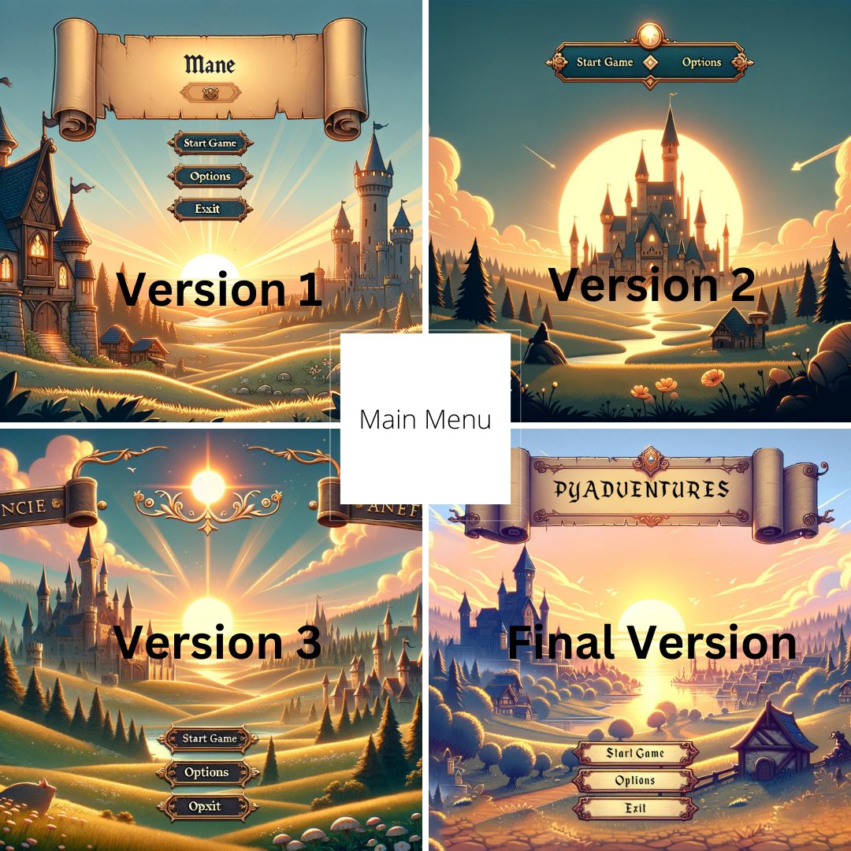

Figure 1Main Menu

## Agile development and prototyping

The PyAdventures dynamic development approach leveraged iterative feedback to enhance the game's educational elements, including the shop system where players spend coins to purchase hints or HP. This feedback guaranteed that the incentives had significance and made a valuable contribution to the learning process. It also helped in making necessary modifications depending on the interactions and preferences of the learners.

The agile approach to development allowed the rapid creation of an early version for the game's map. The initial iteration of the map (Figure 2) was a simple representation. However, after undergoing user testing, it transformed into an extensive and interactive map that effectively directs players throughout their educational progression. The ultimate iteration of the map not only provides clear visual indicators for the players' progress in their Python journey, but also incorporates understated ambient noises that harmonise with the visual components of each step, so enhancing the immersive experience. The sounds played on this scene ‘Lord of the Land’ by Kevin MacLeod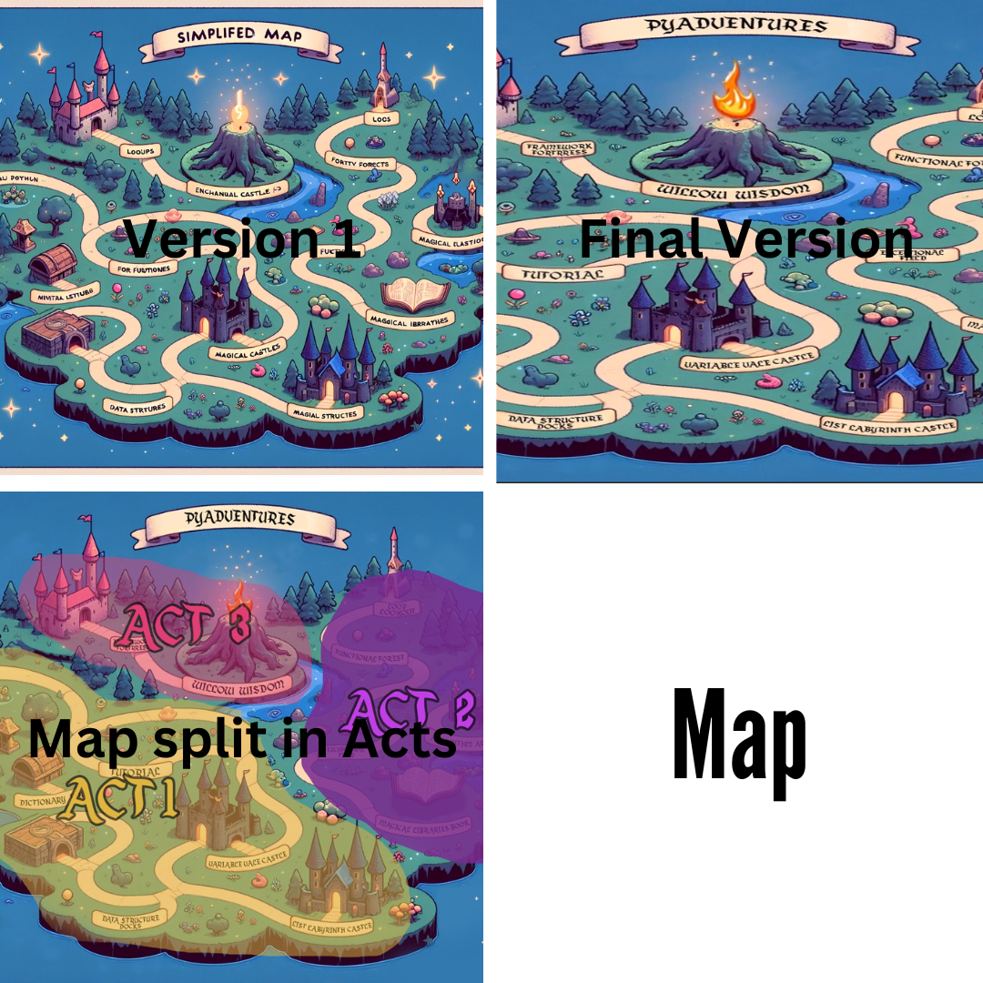

Figure 2 Map Design

## Usability testing and gathering feedback from users

The usability testing phase played a crucial role in improving the instructional difficulties offered to the player. Initially, the questions were simple multiple-choice queries, but they evolved over time into interactive tasks that encourage active learning (Figure 3). Feedback revealed that learners found drag-and-drop coding activities to be highly successful, resulting in its incorporation as an essential component of the learning process in 'PyAdventures'.

Figure 3 Questions Template Design

The introductory dialogue featuring Sir Peter (Figure 4) was designed to greet players and give a concise overview of the aims of the game 'PyAdventures'. The character's role is to provide guidance and support in the story, which is crucial for establishing a strong and instant connection with the educational journey of the game. Feedback on Sir Peter's conversation prompted minor adjustments that elucidated game mechanics and accentuated the adventurous nature of learning Python, guaranteeing that players were adequately equipped and inspired to go on their mission.

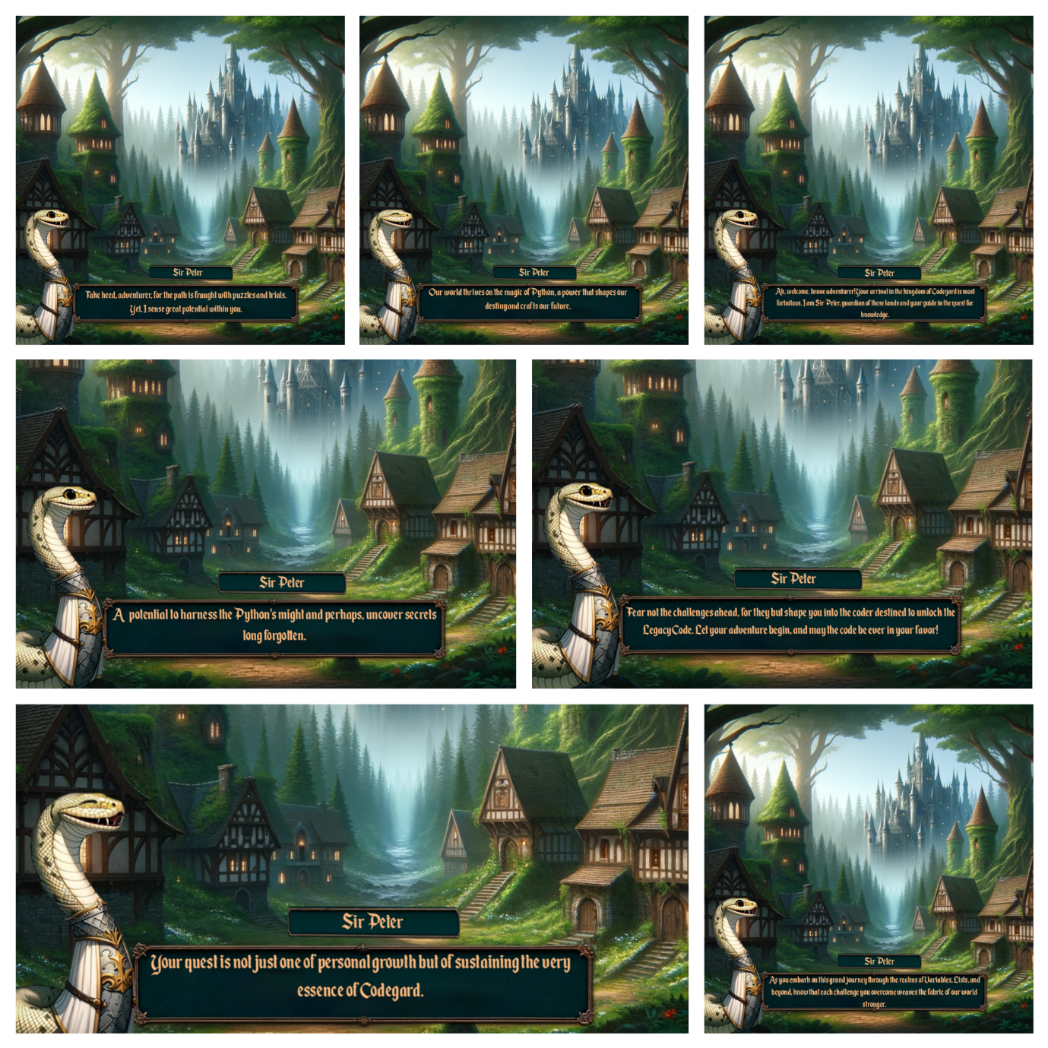

Figure 4 Introduction to PyAdventures by Peter

## Assessing the Impact of Education

The shop located within 'PyAdventures' (Figure 4) serves as a fundamental element of our gamification strategy, allowing players to acquire stuff by making use of coins they have earned via the completion of instructional work. The significance of this motivational tool was emphasised by user comments, which prompted to improve its functionality and visual appeal. The shop's offerings have stayed stable, but its usability and appearance have been enhanced to create a more captivating user experience. 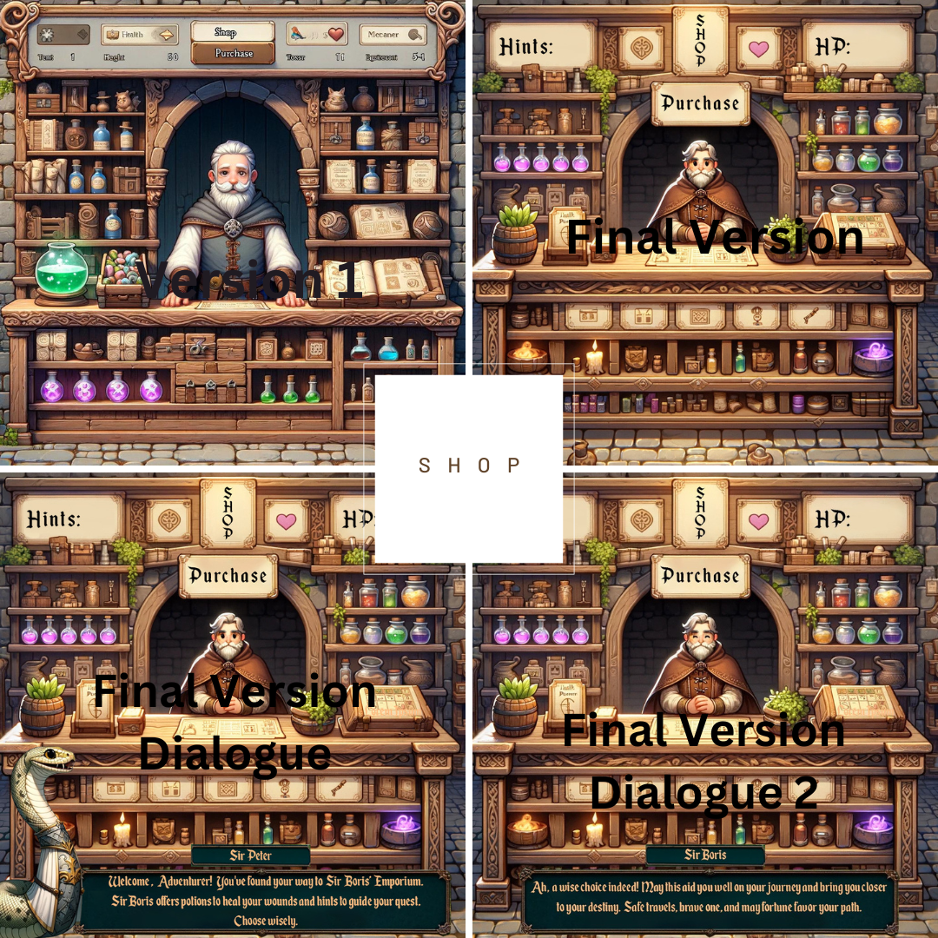

Figure 5 Shop Design and Peter's Introduction to the Shop

## Identifying Limitations and Challenges

During the development of PyAdventures, there were several constraints and difficulties faced that had an impacton the design process and the end result. Recognising these obstacles is essential for comprehending the existing condition of the game and for directing future enhancements.

## Constraints in Technology and Design

The choice to utilise Scratch and Alice 3 for prototyping initially proved advantageous in terms of conceptualising interactive components. However, it eventually imposed limitations on the narrative depth and graphical quality. The adoption of software like as Photoshop and After Effects, although improving the visual attractiveness, resulted in a significant learning curve and prolonged development schedules.

AI-generated artwork provided flexibility for developing a variety of materials but maintaining a consistent style and integrating it with the instructional content of the game posed continuous hurdles. The need to strike a balance between creativity and instructional aims often resulted in compromises in both the design of the game and its efficacy in teaching.

The visual design of 'PyAdventures' has played a crucial role in the game's development since its beginning. The development of the game icon (Figure 6) demonstrates its journey from an initial concept to a perfect educational tool. The game's logo is symbolised by it and serves as the initial point of contact for the player. The ultimate emblem is a vibrant and alluring graphic that effectively encapsulates the core nature of the educational journey it represents. Furthermore, it symbolises the primary concept of the game's theme.

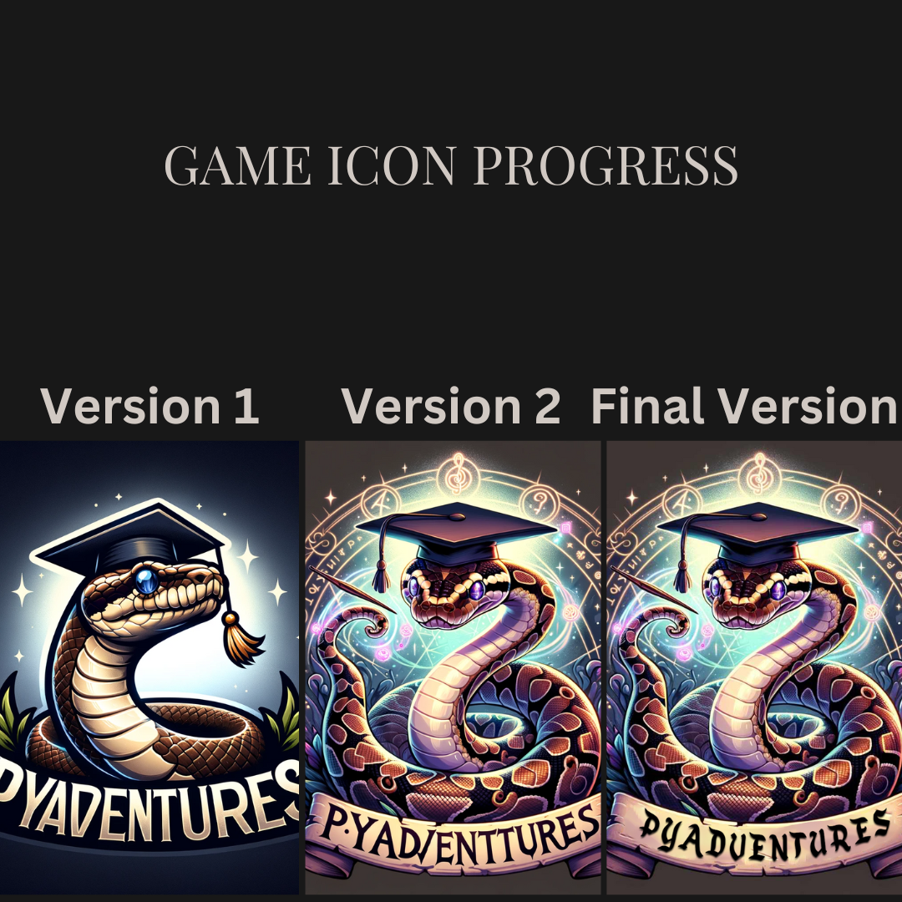

Figure 6 Game Icon Design

Integrating Educational Content:

Achieving a Balance between Education and Engagement an essential obstacle was incorporating Python programming principles that was faced into the game while maintaining a high level of narrative involvement. There were occasions when the instructional information had the potential to interrupt the progression of the game, resulting in modifications to the timing and manner in which certain ideas were presented.

The creation of 'PyAdventures' used evidence-based gamification tactics to cultivate an optimal learning environment. Based on the findings of Welbers et al. (2019), both general feedback and session limits were incorporated to enhance learner engagement without causing them to feel overwhelmed. This approach is consistent with the conclusions drawn from the existing body of research, which indicate that strategically implemented gamification may maintain and potentially improve student engagement with instructional material.

Although 'PyAdventures' offers a range of interactive and functional components, several planned features, such a fully complete choices menu, were limited due to technology and time constraints. The placeholder for the options menu (Figure 5) functions as a prompt for potential areas of growth in future iterations of the game.

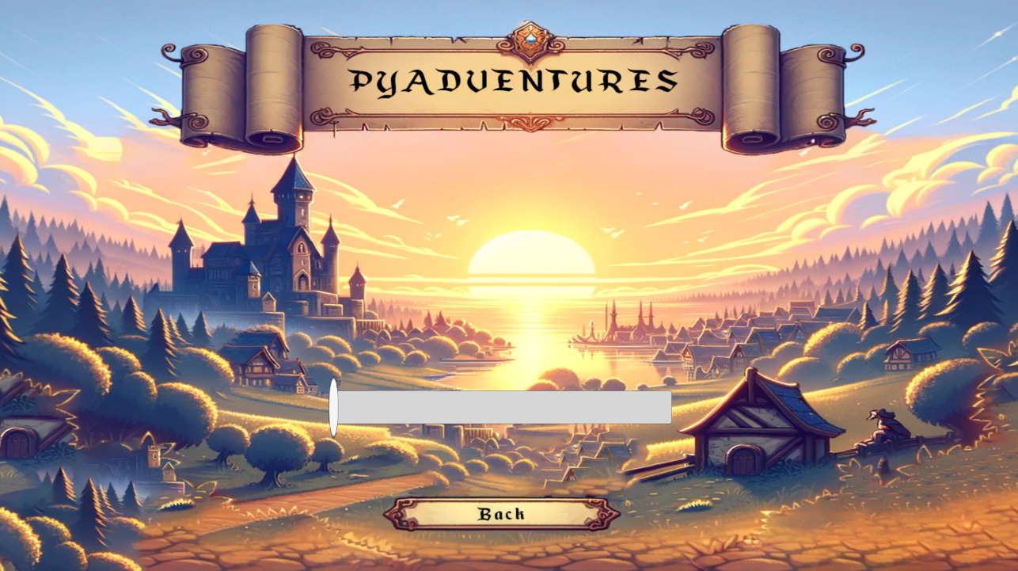

Figure 7 Options Menu

## User feedback on Learning Effectiveness

Although the majority of responses was favourable, there were signs that certain players encountered difficulties with the incorporation of intricate programming principles into the game's framework. This remark emphasises the necessity for more improvement in integrating instructional information into games.

## Challenges in User Experience

Shop System Navigation: Feedback indicated that several players found the shop system, which utilises money for the acquisition of suggestions or supplementary material, rather confusing. This suggests a requirement for more explicit instructions and maybe a more user-friendly design.

The game's adjustable difficulty algorithm, designed to accommodate different learning paces, occasionally led to pacing problems, as some users experienced progress that was either too slow or too quick. This variety highlights the significance of further customising the learning experience.

## Overcoming Constraints in Subsequent Research

The issues and limits that have been discovered serve as the foundation for the existing and future development efforts on PyAdventures. Priorities include enhancing tool integration, improving the balance between instructional information and gaming, streamlining the user experience, and fine-tuning the adaptive difficulty system. Furthermore, the ongoing collection and examination of user input will continue to be a key aspect of the iterative development process, guaranteeing that PyAdventures adapts in accordance with the requirements and preferences of learners.

During the last phases of 'PyAdventures,' the task of closing the game was encountered in a way that was both enjoyable and educationally appropriate. The ending experience was meticulously designed to ensure an effective and meaningful narrative and thematic impact. Sir Peter, the guide during the adventure of mastering Python, delivers a concluding dialogue to the players, commending their accomplishment and motivating them to continue exploring and learning (Introduction Image of the Dialogue). The final 'Thanks for Playing' scene (Figure 7) is intended to evoke a feeling of fulfilment and achievement in participants. The renowned composition 'Conquest of Paradise' by Vangelis is played throughout the credits, metaphorically acknowledging the players' successful overcoming of the obstacles they encountered.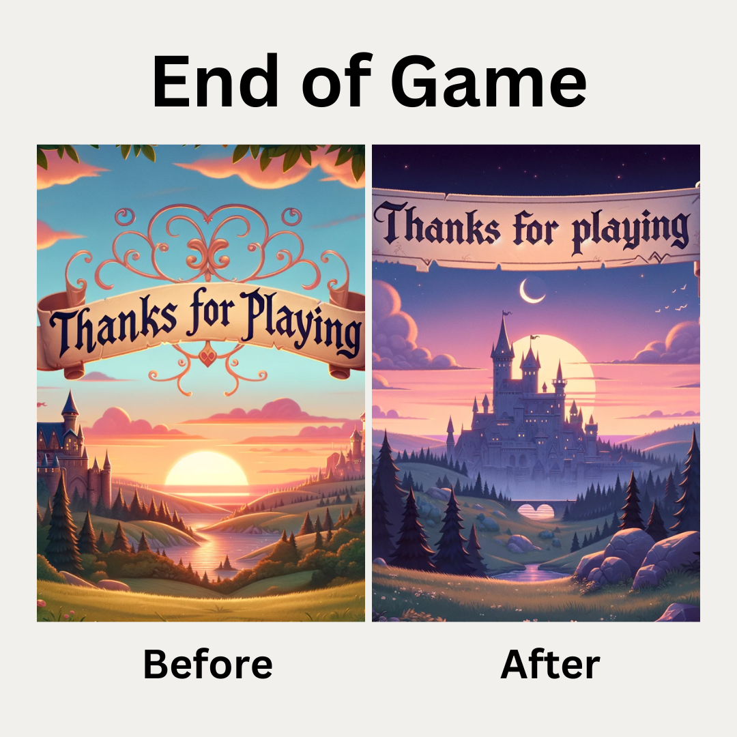

Figure 8 End Of Game Design

# Implementation

## 6.1. Development Tools and Environment

The development of "PyAdventures" involved the use of a diverse range of software tools and technologies to accomplish the requirements for functionality and visual appeal. The Unity game engine was chosen as the primary engine for development due to its strong support for both 2D and 3D game production, as well as its familiar working environment. Other alternatives, such as Alice 3 and Scratch, were considered. However, Unity was chosen because of its superior capabilities and scalability, especially in managing all the complex interactions and graphics needed for "PyAdventures."

Additional tools were important in improving the visual and interaction elements of the game.

DALL-E: This AI programme had a crucial role in creating distinct and thematic visuals that influenced the settings and stages of the game. The graphics underwent additional modification to align with the game's medieval fantasy concept, so assuring a unified visual experience.

Adobe Photoshop: This software was utilized for creating detailed dialogue scenes and editing images generated by DALL-E. Photoshop's powerful editing tools allowed for clear adjustments and enhancements to the game's graphical content.

Adobe After Effects has been used to animate the game map and other interactive scenes, so incorporating dynamic components into the game. The use of motion graphics enhanced the gaming environment by increasing its interactivity and aesthetic appeal.

The storyline and character connection were vividly shown through the dynamic between the characters Sir Peter and Boris:

Sir Peter, a python of noble rank, fulfills the role of the player's guide and acts as the game's mascot. He introduces game levels and offers guidance enhancing the learning experience with a dash of personality.

Boris, the shop-keep, engages with the player within the game's retail establishment, enhancing the game's storyline and offering essential gameplay elements such as acquiring hints or restoring health points.

The background music was sourced from YouTube and chosen with care to enhance the game atmosphere without overshadowing the instructional material. The selected tunes enhanced the gameplay by creating an immersive experience that well complemented the mediaeval fantasy concept.

The incorporation of these different tools and technologies showcases a comprehensive approach towards game production, merging sophisticated technical solutions with imaginative design to provide a captivating and informative experience in "PyAdventures."

## Game Mechanics Implementation

The game "PyAdventures" combines a variety of game concepts that have been carefully developed to enhance the learning process by offering dynamic and captivating gameplay. The educational content of the game's learning environment is based on the Python Programming course offered in the first academic year. It is further enhanced with additional resources from SoloLearn. This integration guarantees that the content is not only instructional but also corresponds to recognised educational requirements.

The game incorporates two primary categories of interactive questions that facilitate the process of gaining knowledge:

Multiple-choice questions are used to evaluate the player's comprehension of Python concepts in a clear and direct manner.

Drag-and-Drop Coding Challenges include players arranging draggable elements in the right sequence to create code lines. This activity encourages a more profound comprehension of syntax and programming logic.

After completing each chapter, players are assessed with concise quizzes that are specifically designed to strengthen and solidify the knowledge they have gained. These exams guarantee that the fundamental principles are well understood prior to progressing to more complex subjects.

In order to inspire and engage players while incorporating aspects of strategic decision-making, "PyAdventures" incorporates a currency system. Players earn coins as a reward for accurately responding to questions, which can be used later at a shop overseen by the non-player character Boris. Within the store, players have the option of purchasing hints or health points, using their accumulated golden coins to effectively solve challenges encountered in the game. This mechanism not only increases involvement but also provides fundamental economic decision-making abilities.

The pinnacle of the game is the "Legacy Code" challenge, an extensive coding exercise that incorporates all the principles acquired during the game. The purpose of this ultimate challenge is to assess the player's capacity to combine and utilise their knowledge in a complex, practical situation. Completing this work remains to be a primary goal, and its effective incorporation will yield a substantial and gratifying conclusion to the gaming experience.

## User Interface and Experience Design

The user interface (UI) of "PyAdventures" has been carefully designed to fully immerse players in a mediaeval fantasy realm, while simultaneously delivering a smooth and educational gaming experience. The main map that players move through, including pictures created by DALL-E, offers a visually immersive setting that enhances the game's concept.

Currently, the accessibility elements, such as back buttons and navigational aids, are unsatisfactory and have been recognised as an area that needs development. An auto-save mechanism is being developed to improve user experience and prevent gamers from losing progress. This system will automatically save and track scores and progress, hence minimising annoyance and improving the usefulness of the game.

## Challenges Encountered

During the development of "PyAdventures," many challenges were faced, specifically in determining the extent of instructional material and the technical execution of game mechanics. During the initial stages of production, extensive study and planning were necessary to establish the educational goals of the game and the curricular areas it would cover.

The implementation of the store system presented considerable technological challenges, particularly in establishing the connection between the coin benefits and the functional features available in the shop. The process of assigning and debugging functions to buttons inside the gaming environment has necessitated iterative testing and development to guarantee functionality and stability. Such challenges have been overcome by using peer cooperation, internet forums, and trial-and-error, which demonstrates the iterative process of game creation.

# Testing and Validation

## 7.1. Testing Strategies

A comprehensive testing process was implemented to guarantee the usefulness and reliability of "PyAdventures." This approach included performing both functional testing, which focused on evaluating the game mechanics, and usability testing, which aimed to evaluate the user experience.

Functional Testing: This phase of testing was dedicated to verifying that all game mechanisms, such as the coin system, shop functionalities, question systems, and final "Legacy Code" challenge, functioned as expected with small issues and glitches. However, they were eliminated as much as possible. Code logic was validated using feedback forum, while manual testing sessions were conducted to uncover any unexpected behaviour in-game interactions.

Usability testing involved gathering qualitative input on the game's interface and general user experience from a sample of target users. The criteria that were tested included the aspects of navigational simplicity, comprehensibility of instructions, and the amount of engagement provided by the game material.

## Users Feedback and Responses

Feedback was methodically gathered through Microsoft form and firsthand observations during playtesting sessions. The main areas of concentration were:

Learning Outcomes: Participants were instructed to provide feedback on their comprehension of programming principles following their gameplay experience.

Player's Interaction with the Game: Feedback was collected to assess general satisfaction and identify areas for improvement in the game's storyline, character involvement (particularly interactions with NPCs like Sir Peter and Boris), and the difficulty level of quizzes and coding work.

## Validation of Educational Objectives

The main educational goal of "PyAdventures" is to efficiently teach Python programming through the use of gamification. The validation of these objectives was accomplished by the comparison of pre-test and post-test outcomes regarding Python proficiency among participants, the observation of the practical use of acquired abilities in game situations, and the evaluation of quiz performance at the conclusion of each chapter. This data was used to verify if the game's educational objectives were being achieved and identified specific areas where more instructional assistance may be required.

## 7.4 Quality Assurance Processes

Quality assurance was a continuous process that occurred during the whole development of "PyAdventures." The task covered:

Conducting regular code reviews to ensure that the game's development follows the most effective coding methods and detects any flaws at an early stage.

Iterative Testing Cycles: Each individual element of the game underwent several iterations of testing and modification, guided by feedback received. This iterative technique facilitated gradual enhancement of the game by incorporating real user feedback.

Performance Testing: The game's performance was carefully evaluated to guarantee a seamless and inclusive learning experience for all players.

# Discussion

## 8.1. Effectiveness of Gamification Techniques

"PyAdventures" effectively uses gamification to enhance the teaching process. The addition of key aspects such as the coin system, interactions with non-player characters (NPCs), and tests at the conclusion of each chapter has been proven to greatly enhance interest and assist the process of learning. The absence of incorporated interactive features such as potions and scrolls is a wasted chance to enhance the gaming and learning experience.

Upon reflection on 'PyAdventures,' the use of gamification strategies, such as the earning of virtual currency and the provision of feedback, closely resembles the favourable results observed in wider educational studies. Contrary to what academic precedents suggest, the individualised feedback in 'PyAdventures' did not show a substantial improvement compared to the generic input. This aligns with the surprising results revealed by Welbers et al. (2019). This disparity underscores the intricate challenge of implementing gamification in diverse educational settings.

"PyAdventures" incorporates many gamification components, including currency and purchasable items. The research conducted by Smiderle et al. (2020) establishes a significant reference point by demonstrating the varying impact of these factors on learners, depending on their individual personality qualities. Through a comparison of the efficacy of these components in "PyAdventures" with the findings of the survey, it can evaluated if the game's features adequately meet the needs of a varied range of users and pinpoint any possible areas that may require modification.

 Evaluating the Impact of Gamification in "PyAdventures"

Upon reviewing the results of Papp et al.'s (2022) study, "PyAdventures" integrates gamification while considering the complex relationship between user involvement and academic output. The study demonstrates that engaging in excessive gaming might result in decreased academic diligence, pointing out the significance of maintaining a balanced approach in gamified learning settings. This insight is essential for assessing the effectiveness of "PyAdventures," indicating that while the game intends to improve learning by promoting active participation, it must also include methods to avoid excessive usage and guarantee that gaming is in line with educational goals.

## 8.2 User Engagement and Learning Outcomes

The feedback obtained from user testing demonstrates that the game effectively captivates players and achieves its instructional objectives. The players have shown a positive reaction to the structured progression via Python concepts. Nevertheless, the lack of a comprehensive options menu restricted many elements of user control and accessibility, hence potentially diminishing the overall user experience.

"PyAdventures" incorporates game components specifically developed to efficiently increase cognitive abilities. For example, the game includes tasks and exercises that need critical thinking and problem-solving skills, closely coinciding with educational goals to enhance cognitive development. Even so, it is important to acknowledge and tackle the possible hazards linked to gaming. This encompasses the potential for developing a gaming addiction, which can result in reduced levels of physical activity and insufficient time management, potentially having a detrimental impact on academic achievement. By comparing these components with the revelations presented in the article, "PyAdventures" may be perceived as a mechanism that not only provides amusement but also imparts knowledge, cultivating proficiencies advantageous for academic accomplishment (The Effects of Video Games on Students’ Cognitive Skills and Academic Performance - Magnetic Magazine, n.d.).

## 8.3 Challenges and Limitations

A major obstacle encountered was the insufficient progress made on the options menu, as a result of time limitations and the prioritisation of essential game features. The game efficiently imparts knowledge of Python, however the restricted range of adaptability may impact the accessibility and comfort of a varied group of players. This problem highlights the significance of thorough feature development in educational games.

The introduction of session limitations, aimed at efficiently distributing learning, presented issues similar to those examined by Welbers et al. (2019). This feature, although effectively prohibiting excessive behaviour, required meticulous adjustment to ensure sustained user involvement during various stages of learning.

## 8.4. Educational Impact

The results obtained by Öztürk and Korkmaz align with the observed outcomes in "PyAdventures." Similar to the study that emphasised enhancements in student attitudes and academic accomplishments through gamification, "PyAdventures" has also demonstrated favourable alterations in learners' involvement and proficiency in Python programming. This parallel highlights the widespread advantages of using gamification in many educational environments and disciplines. Nevertheless, it is essential to acknowledge that although the general patterns are favourable, the precise influence might differ depending on the gamification structure and the characteristics of the students.

Balancing Gaming and Academic Outcomes

Examine how "PyAdventures" may integrate the findings from Wright's research to supervise and regulate the amount of time pupils allocate to gaming. Outline effective methods for incorporating appropriate gaming practices that mitigate the risk of excessive usage, perhaps resulting in diminished academic performance.

Improving the educational influence by implementing gamification

Taking advantage of the discoveries made by Kim and Castelli to advocate for the deliberate use of gamification in "PyAdventures". Highlighting the significance of concise, influential gamified tasks that are in line with educational objectives to enhance cognitive and behavioural results without burdening students.

"PyAdventures" is a programme that teaches Python to players by presenting them with a series of organised tasks. These challenges start with simple ideas and gradually get more advanced, allowing for a thorough learning experience. Every section in the game, which covers a wide range of topics such as fundamental syntax, variables, data structures, and coding concepts, is intentionally structured to build upon previous ones. This approach strengthens learning by providing opportunities for practice and practical use. The game's structure promotes active engagement, which is essential for efficient learning.

Nevertheless, achieving a harmonious blend of comprehensive Python knowledge and captivating gameplay creates difficulties. PyAdventures has the potential of overwhelming students with an excessive amount of material all at once, despite its goal of comprehensively covering Python. In order to tackle this issue, the game integrates variable difficulty levels and quick feedback systems, which effectively sustain student interest while preserving the instructional content's integrity.

# 9. Recommendations

## 9.1 Enhancements for PyAdventures

Future improvements to "PyAdventures" should prioritise the completion of the options menu in order to improve user accessibility and adaptability. The menu should contain the following items:

Audio controls are designed to accommodate users with varying auditory requirements.

Incorporating the originally intended elements, such as potions and scrolls that may be interacted with, could further improve the complexity of the gameplay, resulting in a more dynamic and captivating learning experience.

Based on the findings of Smiderle et al. (2020), it is recommended for "PyAdventures" to include elements like adaptable difficulty levels and personalised feedback systems, taking into account the varying effects of gamification. The objective of these improvements should be to adapt the gaming experience in real-time to accommodate the unique learning speeds and preferences of each individual, hence improving the educational effectiveness for a wide range of learners.

Implement additional adaptive learning functionalities that dynamically modify the level of difficulty in tasks, considering the player's progress and success in quizzes. This adjustability guarantees that students are neither under-stimulated nor overburdened.

Creating a modular course within the game that offers students the opportunity to select courses that align with their unique interests, so enhancing the personalised and engaging nature of the learning experience.

Developing and include system measures that prohibit and identify common cheating techniques, so guaranteeing that players genuinely interact with the material.

Employing distinct problem sets for individual players wherever possible, so diminishes the effectiveness of solution sharing and encouraging genuine problem-solving.

Providing students who successfully finish the fundamental course content with the option to engage in "expert-level" challenges or extensions, allowing them to delve deeper into the subject matter without excessively burdening the primary educational experience.

Organising community activities or competitions that motivate gamers to utilise Python in new and inventive manners, cultivating a more profound affinity with the subject matter.

Feedback mechanisms are processes that allow for the collection and analysis of information in order to make improvements. Continuous improvement refers to the ongoing effort to enhance and refine a system or process.

Implementing a comprehensive feedback mechanism within the game that allows users to effortlessly report glitches, propose enhancements, or offer instructional input.

Consistently refresh the game material to align with the most recent advancements in Python and instructional methodologies, ensuring that the learning environment remains up-to-date and relevant.

## 9.2 Future Research Directions

Additional investigation might examine the influence of a more extensive choices menu on educational achievements and user contentment. Studies might also evaluate the effectiveness of additional gamification aspects by comparing the standard version of the game to an upgraded version that has all intended interactive features.

According to the systematic assessment of gamification's effects on education, future versions of 'PyAdventures' should investigate more detailed feedback systems and improve session limitations to better suit various learning styles. In addition, future study might explore the circumstances in which customised feedback may have a greater impact, perhaps resulting in more individualised and adaptable learning experiences.

Additional research is required to examine the enduring impacts of tailored gamification on educational achievements in "PyAdventures." Additional gamification features should be evaluated to ascertain their influence on various learner profiles. Future versions of "PyAdventures" might use advanced gamification approaches, based on the successful strategies outlined in "Play Hard, Study Hard," to enhance engagement and promote educational achievement.

Based on the achievements documented by Öztürk and Korkmaz, it is advised that "PyAdventures" enhances its gamification tactics by including additional components that foster collaborative learning. To further increase the educational value of the game, it would be beneficial to incorporate comparable methods, such as team-based challenges or multiplayer situations, that require learners to interact in order to solve difficulties. This is supported by the considerable improvement in cooperative abilities shown in the research. Furthermore, these tactics are in accordance with constructivist learning theories that promote active engagement and social collaboration in the learning process.

Development of Moderation Tools

Considering the implementation of in-game functionalities that promote moderation and effective time management, making use of insights from Wright's research. Possible features might encompass pop-ups or gameplay mechanisms that restrict the duration of gameplay according to academic timetables or incorporate actual academic due dates into the game.

Enhancing the effectiveness of gamification strategies

Employing the research conducted by Kim and Castelli, propose improvements to "PyAdventures" that prioritise immediate and significant gamification tactics. Take into account the integration of digital badges, leaderboards, and other incentive features that have been proven to significantly enhance engagement and encourage educational achievement.

## 9.3 Potential Applications

Expanding the functionality of "PyAdventures" through the addition of a comprehensive options menu and introducing other game elements has the potential to greatly broaden its usefulness in educational environments. The game has the potential to be modified for educational purposes in schools, coding boot camps, and online platforms. It can serve as a versatile and inclusive learning tool that can be customised to cater to various learning styles and requirements.

Strategic Enhancements for 'PyAdventures':

Incorporate Active Learning Tasks: Create game levels that demand active participation and critical thinking, directly aligned with educational objectives, to promote cognitive growth without overwhelming the learner.

Encourage Responsible Gaming Practices: Incorporate game elements that motivate players to take frequent breaks and efficiently control their time spent gaming. This may encompass characteristics that incentivize players for maintaining a harmonious balance between engaging in the game and participating in other scholastic activities.

Promote Physical Activity: Given the predominantly inactive character of several video games, "PyAdventures" might incorporate prompts or rewards to encourage physical exercise. This might aid in alleviating one of the notable disadvantages of excessive gaming.

Time Management Tools: Offer in-game resources that assist gamers in efficiently managing their time. This might encompass including strategic planning and time management elements into the game, which motivate players to effectively allocate their time between gaming and academic obligations.

Sleep Hygiene Education: Provide players with interactive in-game information to educate them about the significance of cultivating healthy sleep habits. This educational programme might emphasise the impact of sleep on cognitive function and academic achievement, underscoring the need of sufficient rest (The Effects of Video Games on Students’ Cognitive Skills and Academic Performance - Magnetic Magazine, n.d.).

Offering conducting more research to investigate the enduring impacts of gamification on academic performance, especially in varied educational environments. This might aid in the optimisation of gamification tactics in "PyAdventures" and their customisation to various educational settings and student demographics.

# 10. In Conclusion

The literature study highlights the potential of gamification as an innovative approach in programming education. The material points out the significance of internal motivation, engaged learning, and the deliberate use of gamification components. PyAdventures is an innovative programme that focuses on using storytelling and practical examples to teach programming ideas, making it a significant advancement in this discipline. By addressing the shortcomings that have been discovered, this contributes to the current discussion on successful ways for teaching programming. It holds the potential to provide a more inclusive, interesting, and effective learning experience for novices. Recognising and resolving the possible disadvantages of incorporating gamification into programming instruction is essential for the creation of impactful educational games. PyAdventures aims to address these difficulties by providing a gamified learning platform that is both interesting and instructional, with a specific focus on developing a deep understanding and proficiency in Python programming.

PyAdventures enhances the domain of instructional programming games by combining a captivating storyline, coding assignments based on text, and a groundbreaking store system to construct a stimulating and immersive learning environment. The program's emphasis on narrative-based learning and customisable material sets it apart from similar programmes, providing learners with not just the ability to code but also the inspiration and assurance to begin their programming adventure with eagerness and self-assurance. PyAdventures seeks to motivate a new cohort of learners to delve into the realm of Python programming by combining the educational rigour of programming with the immersive enjoyment of gaming.

The technique employed for PyAdventures demonstrates a dedication to developing an educational game that is both captivating and pleasurable, while also being firmly rooted in pedagogical excellence. By employing iterative design, doing extensive user testing, and conducting a thorough evaluation of educational results, PyAdventures has been improved to become a tool that guarantees to make the process of learning Python programming accessible and entertaining for novices.

The concept and implementation of "PyAdventures" demonstrate a profound comprehension of the educational possibilities of gamification. Through further optimisation of the integration of extensive educational content and captivating gameplay, "PyAdventures" can continue to serve as a very effective instrument for teaching Python programming. In order to guarantee that "PyAdventures" efficiently teaches Python and also encourages a long-lasting interest in programming, the game's development team must diligently consider the learners' demands and stay updated on the current best practices in educational technology.

**List of References**

Kapp, K. (2012). The gamification of learning and instruction: Game-based methods and strategies for training and education. San Francisco: Wiley.

Zainuddin, Z., Chu, S.K.W., Shujahat, M. and Perera, C.J. (2020). The impact of gamification on learning and instruction: A systematic review of empirical evidence. Educational Research Review, 30(2020), p.100326. doi:https://doi.org/10.1016/j.edurev.2020.100326.

Welbers, K., Konijn, E. A., Burgers, C., de Vaate, A. B., Eden, A., & Brugman, B. C. (2019). Gamification as a tool for engaging student learning: A field experiment with a gamified app. E-Learning and Digital Media, 16(2), 92-109. https://doi.org/10.1177/2042753018818342

Zeybek, N., & Saygı, E. (2024). Gamification in Education: Why, Where, When, and How?—A Systematic Review. Games and Culture, 19(2), 237-264. <https://doi.org/10.1177/15554120231158625>.

Chen, J. and Liang, M. (2022). Play hard, study hard? The influence of gamification on students’ study engagement. Frontiers in Psychology, 13. doi:https://doi.org/10.3389/fpsyg.2022.994700.

Smiderle, R., Rigo, S.J., Marques, L.B. et al. The impact of gamification on students’ learning, engagement and behavior based on their personality traits. Smart Learn. Environ. 7, 3 (2020). <https://doi.org/10.1186/s40561-019-0098-x>.

Korkmaz, Ö., & Öztürk, Ç. (2020). The Effect of Gamification Activities on Students’ Academic Achievements in Social Studies Course, Attitudes towards the Course and Cooperative Learning Skills. Participatory Educational Research, 7(1), 1-15. <https://doi.org/10.17275/per.20.1.7.1>.

Papp, D., Győri, K., Kovács, K.E. and Csukonyi, C. (2021). The effects of video gaming on academic effectiveness of higher education students during emergency remote teaching. Hungarian Educational Research Journal. doi:https://doi.org/10.1556/063.2021.00101.

The Effects of Video Games on Students’ Cognitive Skills and Academic Performance - Magnetic Magazine. (n.d.). Magnetic Magazine. [online] Available at: <https://www.magneticmag.com/2023/07/the-effects-of-video-games-on-students-cognitive-skills-and-academic-performance/>.

Wright, Jancee (2011) "The effects of video game play on academic performance," Modern Psychological

Studies: Vol. 17 : No. 1 , Article 6.

Available at: <https://scholar.utc.edu/mps/vol17/iss1/6>.

Kim J, Castelli DM. Effects of Gamification on Behavioral Change in Education: A Meta-Analysis. Int J Environ Res Public Health. 2021 Mar 29;18(7):3550. doi: 10.3390/ijerph18073550. PMID: 33805530; PMCID: PMC8037535.

Metwally, A.H.S., Nacke, L.E., Chang, M., Wang, Y. and Yousef, A.M.F. (2021). Revealing the hotspots of educational gamification: An umbrella review. International Journal of Educational Research, [online] 109, p.101832. doi:https://doi.org/10.1016/j.ijer.2021.101832.

Nadi-Ravandi, S. and Batooli, Z. (2022). Gamification in education: A scientometric, content and co-occurrence analysis of systematic review and meta-analysis articles. Education and Information Technologies. doi:https://doi.org/10.1007/s10639-022-11048-x.

Prensky, M. (2006). Don’t Bother Me Mom--I’m Learning! Paragon House Publishers.

Mcgonigal, J. (2012). Reality is broken: why games make us better and how they can change the world. London: Vintage.

Gee, J.P. (2007). What video games have to teach us about learning and literacy. Palgrave Macmillan.

Miguel Angel Garcia-Ruiz (2017). Games User Research. CRC Press.

James Paul Gee (2007). Good video games + good learning : collected essays on video games, learning, and literacy. New York: P. Lang.

Lebowitz, J. (2017). INTERACTIVE STORYTELLING FOR VIDEO GAMES : a player-centered approach to creating memorable ... characters and stories..